Exp: 10 Configure the Standard and Extended Access Control List using cisco packet tracer and verify the configuration

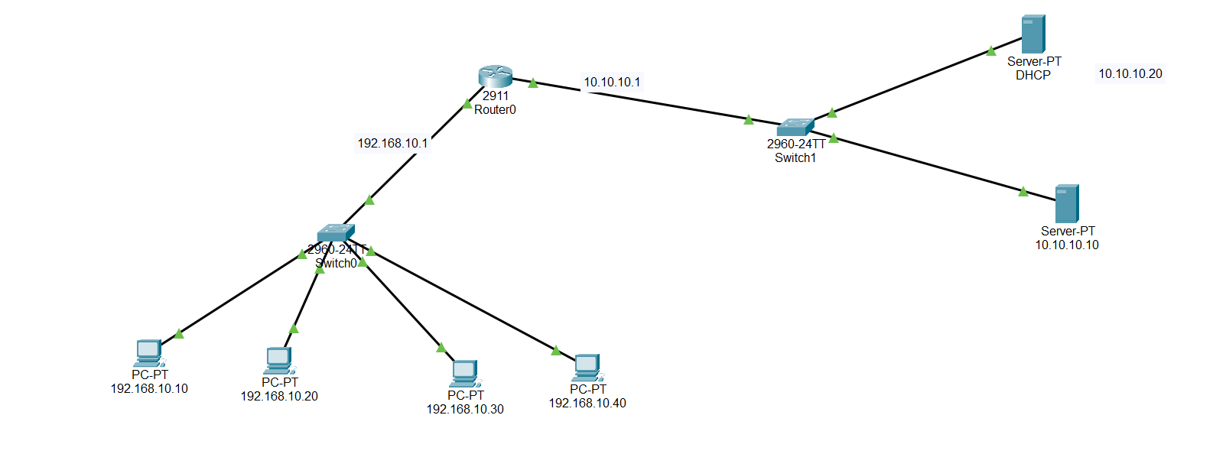
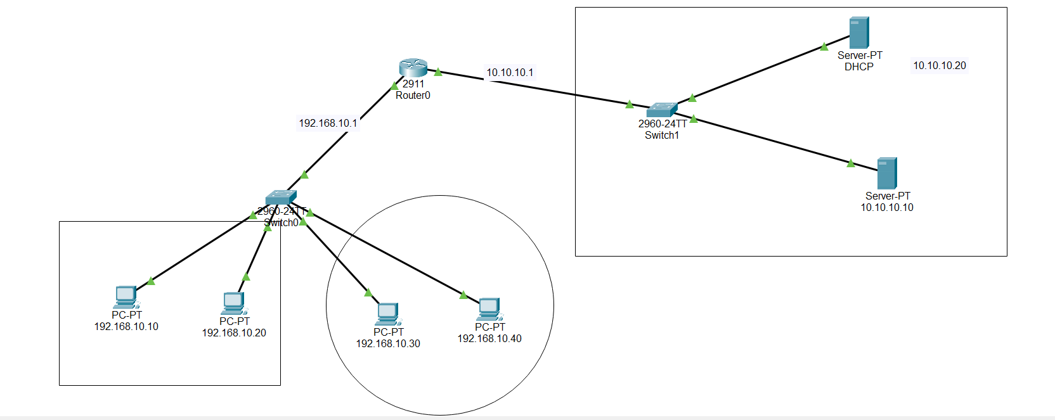

Router:
Router(config)#access-list 10 permit host 192.168.10.10
Router(config)#access-list 10 permit host 192.168.10.20
Router(config)#access-list 10 deny any
Router(config)#int gig0/0
Router(config-if)#ip access-group 10 in
Router(config-if)#exit
Router(config)#do wr
Router(config)#exit
Router#sh access-lists
Standard IP access list 10
10 permit host 192.168.10.10 (8 match(es))
20 permit host 192.168.10.20
30 deny any (8 match(es))
